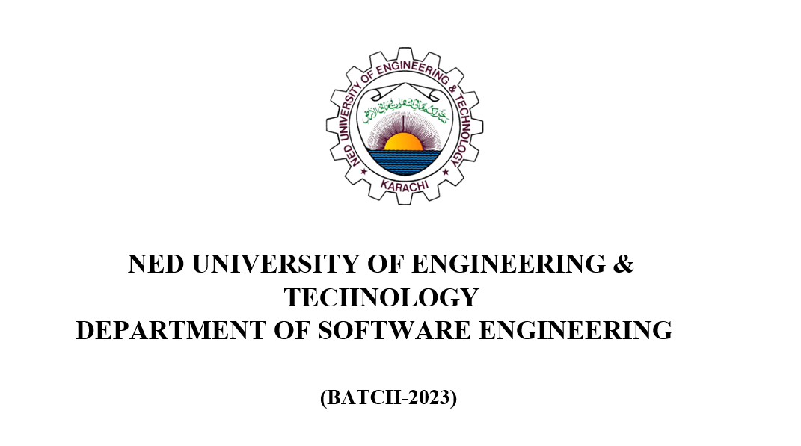

Data Structure and Algorithm

(DSA)

Course Code: CT-157

Course Instructor: Miss Ruqqiya Asad

Section: B

LAB: 01 To 02

Muhammad Muzamil

SE-24083

